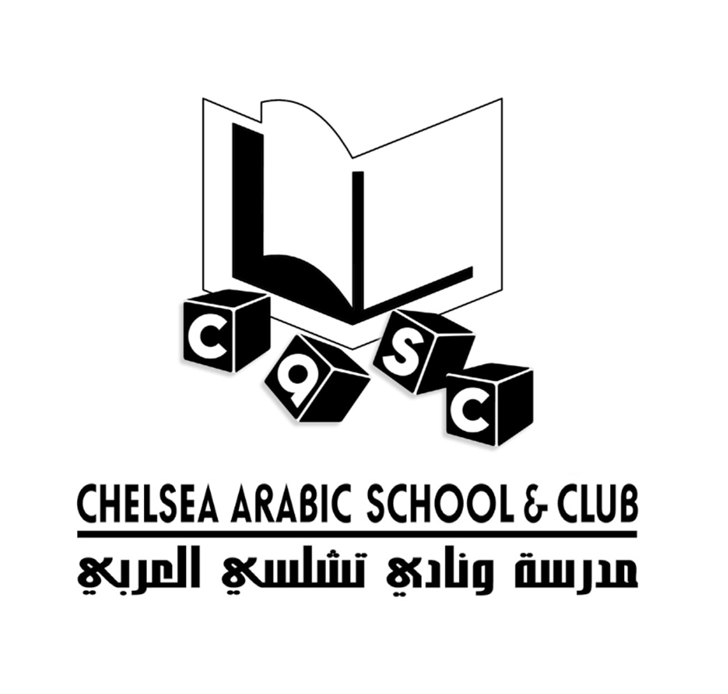

Chelsea Arabic School and Club Ltd
Supplementary School

Registration form

Data Protection Act:
▪ This information is being collected so that we can contact you if your child is ill or hurt; so that we can put your child in the right class for his or her age group; and so that we can track your child’s attendance and progress.

▪ This Supplementary School will not identify your child in any way, or give your child’s name to any outside organisation. We shall not contact your child’s mainstream school without your permission in writing.

Child’s Name ______________________________________________________

Weekday (mainstream) School attended ___________________________________

Year group _____________________ Date of Birth ________________________

Boy / Girl ________________________

Parent’s Name ___________________________________________________

Address ___________________________________________________

___________________________________________________

Parent’s E-mail address

Telephone number ___________________________________________________

Emergency telephone number and contact name _______________________________________

Emergency telephone number and contact name (2)

Other information we should know (eg medical condition, diet, learning difficulties)

* I the parent/ carer of year Date of Birth

I hereby give/ don’t give permission for a representative of Chelsea Arabic School and Club Ltd to take to hospital in case of an emergency.

I understand that Chelsea Arabic School and Club Ltd will contact me in the event of an emergency situation.

Signed ___________________________________ Date _________________

27 Cornwall Gardens, London
SW7 4AW Telephone:07958 660 571
27 Cornwall Gardens, London
SW7 4AW Telephone:07958 660 571
27 Cornwall Gardens, London
SW7 4AW Telephone:07958 660 571

* I the parent/ carer of year Date of Birth

I hereby give/ don’t give permission for a representative of Chelsea Arabic School and Club Ltd to take to hospital in case of an emergency.

I understand that Chelsea Arabic School and Club Ltd will contact me in the event of an emergency situation.

Signed ___________________________________ Date _________________

* Please Note: the school doesn’t provide food; parents are advised to send lunch in preserved packed lunch boxes, also you need to send a labelled bottle of water with the child’s name on.

27 Cornwall Gardens, London
SW7 4AW Telephone:07958 660 571

